**Motion Planning – Assignment 1 – Programming Portion**

**Ravikiran Janardhana**

**Implement and Evaluate the PRM Algorithm**

**1) Analysis of Test Case 1**

The below graph demonstrates the relationship between n (number of milestones) and the shortest path length found by the PRM planner for Test Case 1.

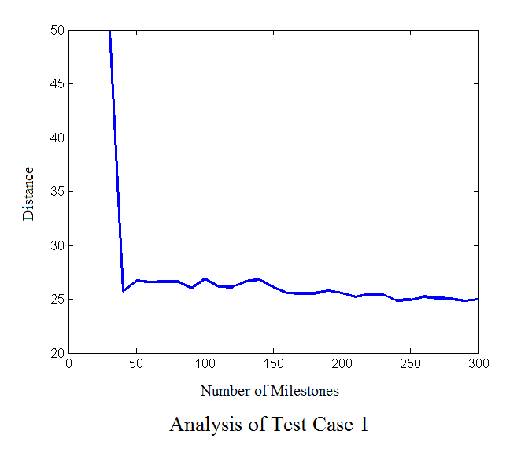

It can be easily noticed that the PRM planner gives the shortest path length as ‘infinity’ until number of milestones crosses a threshold, which is 40 in the above case. This is because the planner cannot find a suitable set of uniformly distributed random points which have ‘m’ (=10) nearest neighbors.

As you increase the number of samples above the threshold, the shortest path length decreases and we get nearly optimal solution at n=300. If n is further increased (n=450-500), the PRM planner gives the shortest path length as ‘infinity’. This is because the PRM fails to find ‘m’(=10) nearest neighbors for each point in the huge point set.

**2) Analysis of Test Case 2**

The below graph demonstrates the relationship between n (number of milestones) and the shortest path length found by the PRM planner for Test Case 2.

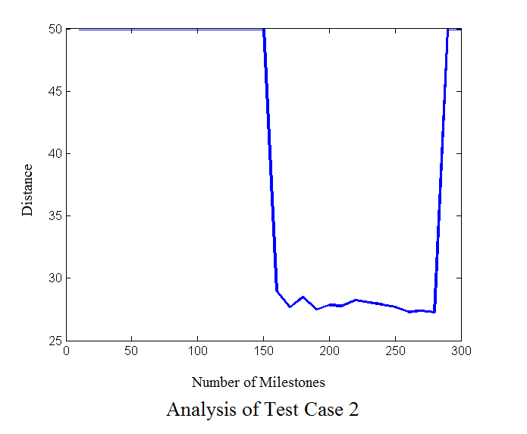

From the above graph, it is clear that the PRM planner gives the shortest path length as ‘infinity’ until number of milestones crosses a threshold, i.e., 160 in the above case. This is because of two reasons namely:-

1) The planner cannot find a suitable set of uniformly distributed random points which have ‘m’ (=10) nearest neighbors.

2) There is a narrow region between the obstacles in Test Case 2, if no point is sampled in this narrow region, the resulting graph generated will be disconnected and hence no path would exist between start and end point. However, this means that a path may or may not exists between start and end point.

As you increase the number of samples above the threshold, the shortest path length decreases and we get nearly optimal solution at n=260. If n is further increased (n=300-500), the PRM planner gives the shortest path length as ‘infinity’ again. This is because the PRM fails to find ‘m’(=10) nearest neighbors for each point in the huge point set.

**Comparison of the Graphs (Test Case 1 and Test Case 2)**

The “Test Case 1 graph” has a larger window of milestones where the shortest path between start and end point can be found such that the shortest path length is not equal to infinity. This is because there are no narrow regions in between obstacles along the path from start to end point.

In “Test Case 2 graph”, there is a narrow window of milestones where the shortest path between start and end point can be found such that the shortest path length is not equal to infinity. This is because of the narrow region between Obstacle-2 (7, 0, 12, 10) [xmin, ymin, xmax, ymax] and Obstacle-3(8, 12, 13, 22) which is along the path from start to end point.